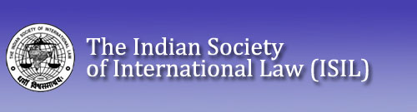

**CALL FOR PAPERS**

**ISIL YEAR BOOK OF INTERNATIONAL HUMANITARIAN AND REFUGEE LAW**

**VOL. XXIV 2024**

The Indian Society of International Law (ISIL) publishes ISIL Year Book of International Humanitarian and Refugee Law (IYBIHRL) annually, focusing on the development of international humanitarian law (IHL) and refugee law. Besides articles, notes and comments, book reviews, the Year Book also contains important documents and bibliography on the subjects during the year under review. Prof. (Dr) Manoj Kumar Sinha is the Chief Editor of the Year Book.

The Editorial Board of IYBIHRL is pleased to invite submissions in the form of articles, notes and comments and book reviews on contemporary humanitarian and refugee law issues.

Article: 8,000-15,000 words.

Notes and comments: 3,000-7,000 words.

Book Reviews: 1500-3000 words

Submissions for Volume XXIV 2024 should reach at [yearbookisil@gmail.com](mailto:yearbookisil@gmail.com) latest by 30 November, 2024

However, submissions will be considered on a rolling basis.

Contributions must be original unpublished works and submission of contributions will be held to imply this. Manuscripts must be word-processed and in compliance with the IJIL guidelines. The guidelines are available online at: [Guidelines.pmd (isil-aca.org)](https://www.isil-aca.org/download/2021/IJIL%20guidelines.pdf)

Submissions should be provided in English, using MS Word-compatible word processing software, and delivered by email to the Chief Editor/Managing Editor at [yearbookisil@gmail.com](mailto:yearbookisil@gmail.com)